Sound - 02
CLASS 08 - SCIENCE

 | Section A
1 | Read the text carefully and answer the questions: The to and fro motion of an object is known as vibration. This motion is also called oscillatory motion.Take a metallic tumbler and a tablespoon. Strike the tablespoon gently at the brim of the tumbler. Hear the sound produced. Now bang the spoon on the tumbler and hear the sound produced again. Is the sound louder when the tumbler is struck hard. 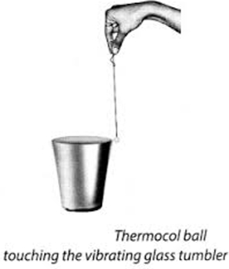  - The maximum displacement of a body from its mean position is called  - a) periodic motion  - b) oscillation  - c) frequency  - d) amplitude  - 1 hertz equal to  - a) 1 vibration per minute  - b) 60 vibrations per minute  - c) 10 vibrations per minute  - d) 600 vibrations per minute  - Frequency is expressed in  - a) litre  - b) hertz  - c) meter  - d) seconds  - The number of oscillations per second is called the ________.  - The frequency determines the shrillness or pitch of a sound. | [5]
2 | Read the text carefully and answer the questions: Sunita has buy a new house near industrial area. She is very fed - up as during day as well as night unnecessary sound come. They are the loud sound which usually irritate her. She want to create awareness so she gathered the neighbouring people and write slogan about what are the harmful effect of the sound and she also filles complaint about this.  - Which of the following does not produce noise pollution?  - a) Reading book  - b) Television at high volume  - c) burning of crackers  - d) loudspeakers  - Which of the following measure can be taken to limits the noise pollution?  - Noise producing industries should be set up away residential area  - Use of automobile horns should be minimised.  - Both (a) and (b)  - Deforestation  - a) Option (c)  - b) Option (b)  - c) Option (d)  - d) Option (a)  - Noise pollution can leads to  - a) Anxiety  - b) Low vision  - c) Hypertension  - d) All of these  - Too much noise in our surroundings that causes discomfort is called ________.  - Above 80db the noise becomes physically painful. | [5]
3 | Read the text carefully and answer the questions: An activity is been demonstrated by the teacher in the class in which she follows the following step Step 1 - Take a rubber band. Put it around the longer side of a pencil box Step 2 - Insert two pencils between the box and the stretched rubber. Step 3 - Now, pluck the rubber band somewhere in the middle. 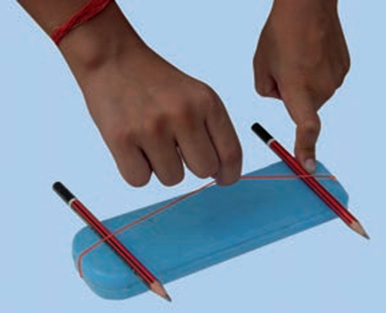  - What is demonstrated by the activity shown above?  - a) All of these  - b) Sound is Produced by a vibrating Body  - c) Sound needs medium propagation to travel  - d) Sound Produced by Humans  - Which of the following is the musical instruments?  - a) Cymbals  - b) All of these  - c) Mudpots  - d) Ghatam  - Sound is a kind of  - a) Pressure  - b) Energy  - c) Force  - d) Work  - The to and fro or back and forth motion of an object is called ________.  - When a tightly stretched band is plucked, it vibrates and produces sound. | [5]
4 | Read the text carefully and answer the questions: Rena wants to understand how sound are produced through vocal cord so she performed following activity Step 1 - Take two rubber strips of the same size. Step 2 - Place these two pieces one above the other and stretch them tight. Step 3 - Now blow air through the gap between them. As the air blows through the stretched rubber strips, a sound is produced. Step 4 - You can also take a piece of paper with a narrow slit and hold it between your fingers. Step 5 - . Now blow through the slit and listen to the sound. 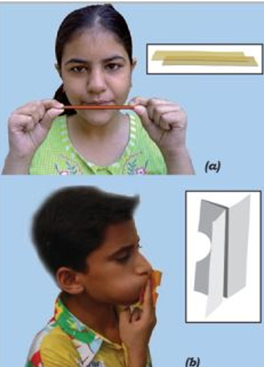  - The voice box is also called as  - a) Stomach  - b) Larynx  - c) Mouth  - d) Heart  - Cochlea is a part of  - a) air pollution  - b) hearing organ  - c) muscular organ  - d) sound producing organ  - The hearing range of human ear is  - a) 20 Hz to 20,000 Hz  - b) more than 20,000 Hz  - c) less than 20 Hz  - d) 20 Hz to 25,000 Hz  - Two ________ are stretched across the voice box or larynx in such a way that it leaves a narrow slit between them for the passage of air.  - Muscles attached to the vocal cords can make the cords tight or loose. | [5]
5 | Read the text carefully and answer the questions: Anita take a bucket or a bathtub. She fills it with clean water. Take a small bell in one hand. She then shakes this bell inside the water to produce sound. Make sure that the bell does not touch the body of the bucket or the tub. 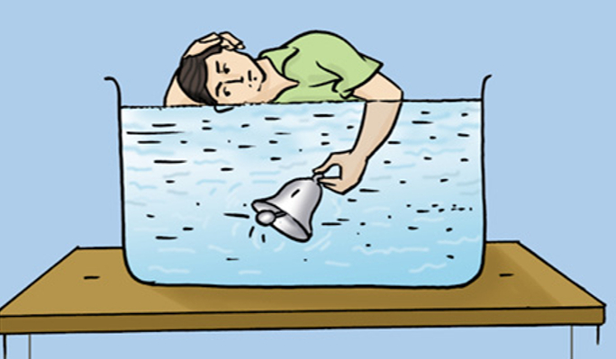  - Sound cannot travel through.  - a) iron  - b) air  - c) vacuum  - d) water  - Loudness of sound is determined by  - a) Pitch  - b) Amplitude  - c) Time period  - d) Frequency  - What is demonstrated the activity shown above?  - a) Sound needs medium propagation to travel  - b) Sound is Produced by a vibrating Body  - c) Sound Produced by Humans  - d) All of these  - The toy telephone that we made in our childhood the sound travel through ________.  - Sound cannot travel through strings. | [5]
 | Section B
6 | Match the items given in Column A with those in Column B suitably: 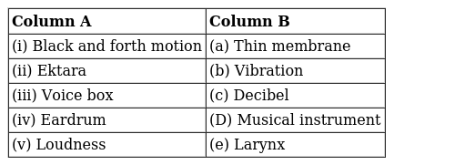 | [2]
7 | Match the following: 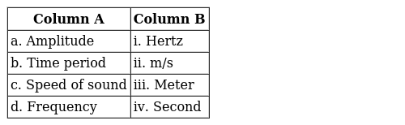 | [2]
8 | Match the following: 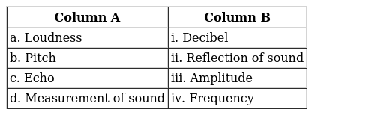 | [2]
9 | Matching the following: 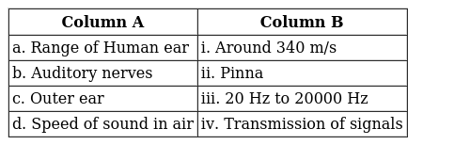 | [2]
10 | Match the following: 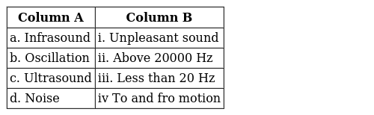 | [2]
11 | Match the following: 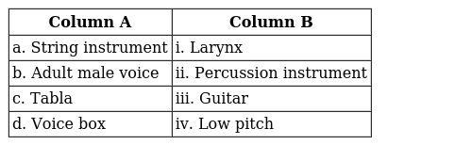 | [2]
12 | Match the items given in Column A with those in Column B suitably: 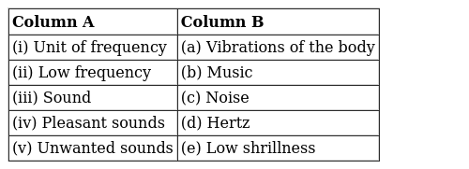 | [2]
 | Section C
13 | How do human being hear the sounds? | [2]
14 | Prove that sound needs a medium for propagation. | [2]
15 | We have learned that vibration is necessary for producing sound. Explain why the sound produced by every vibrating body cannot be heard by us? | [2]
16 | Explain the principle on which Jaltrang work. | [2]
17 | Your parents are going to buy a house. They have been offered one on the roadside and another three lanes away from the roadside. Which house would you suggest your parents should buy?Explain your answer. | [2]
18 | What is ektara? Identify its vibrating part. | [2]
19 | Explain in what way noise pollution is harmful to humans. | [2]
20 | What is noise pollution? | [2]
21 | Identify the part which vibrates to produce sound in the following instruments:(a) Dholak (b) Sitar (c) Flute | [2]
22 | Do you see the vibrations in all the cases? | [2]
23 | The sound from a mosquito is produced when it vibrates its wings at an average rate of 500 vibrations per second. What is the time period of the vibration? | [2]
24 | We have a stringed musical instrument. The string is plucked in the middle first with a force of greater magnitude and then with a force of smaller magnitude. In which case would the instrument produce a louder sound? | [2]
25 | How can noise pollution be controlled? | [2]
26 | List sources of noise pollution in your surroundings. | [2]
27 | Lightning can be seen the moment it occurs. Paheli observes lightning in her area. She hears the sound 5 s after she observed lightning. How far is she from the place where lightning occurs? (speed of sound = 330 m/s). | [2]
28 | List three sources of noise pollution in your locality. | [2]
29 | Lightning and thunder take place in the sky at the same time and at the same distance from us. Lightning is seen earlier and thunder is heard later. Can you explain? | [2]
30 | Name the organ in human that produces sound. How does it work? | [2]
31 | What is echolocation? | [2]
32 | What do you mean by noise and musical sound? | [2]
33 | What are the consequences of noise pollution? | [2]
34 | What are musical instruments? How do they produce sound? | [2]
35 | Prove that sound can travel through the liquids. | [2]
36 | What is the difference between noise and music? Can music become noise sometimes? | [2]
37 | What is frequency? How does it affect the quality of sound? | [2]
38 | A simple pendulum makes 10 oscillations in 20 seconds. What is the time period and frequency of its oscillation? | [2]
39 | What are the two important properties of sound? | [2]
40 | How is sound produced? | [2]
41 | Prove that sound can travel through solids. | [2]
42 | What do you mean by vacuum? What happens to the loudness of sound in vacuum? | [2]
43 | How does loudness of sound is affected by amplitude? | [2]
44 | Could you able to hear sound on the surface of moon? | [2]
45 | Sketch larynx and explain its function in your own words. | [2]
46 | How does shrillness or pitch is affected by frequency? | [2]
47 | Suppose a stick is struck against a frying pan in a vacuum. Will the frying pan vibrate? Will we be able to hear the sound? Explain. | [2]
48 | Two astronauts are floating close to each other in space. Can they talk to each other without using any special device? Give reasons. | [2]
49 | How can we control noise? | [2]
50 | Boojho saw a cracker burst at night at a distance from his house. He heard the sound of the cracker a little later after seeing the cracker burst. Give reason for the delay in hearing the sound. | [2]
51 | Explain with the help of an activity that vibrating bodies produce sound. | [2]

